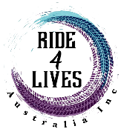
Brought to you by Ride4Lives Australia Inc and supported by Strong Communities, StandBy Support, Marcus Mission, Port Curtis Rotary’s Project We Care, Gladstone Suicide Bereavement Support Group & Gladstone Region Awareness and Suicide Prevention (GRASP).
Ride4Lives Australia Inc presents
SUICIDE PREVENTION WEEK
9-16 SEPTEMBER 2021
SUICIDE PREVENTION WEEK CALENDAR SEPTEMBER 2021
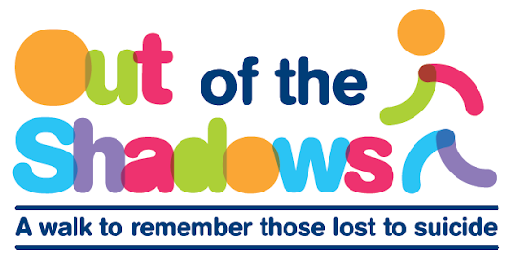
All Activities Listed are FREE Events
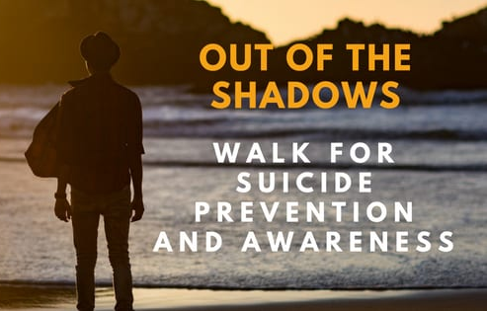
Ride4Lives are hosting the Gladstone 2021 Out of the Shadows Walk
Sunday 12 September 2021
5.00am
Meet at East Shores

Join us in the Out of the Shadows Walk – Lifeline’s national suicide prevention walk. It is a walk of remembrance and hope as we meet a new sunrise. Raise awareness, remember those lost to suicide, and unite in a commitment to prevent further deaths by suicide.
Thurs  9 | Fri  10 | Sat  11 | Sun  12 | Mon  13 | Tues  14 | Wed  15 | Thurs  16
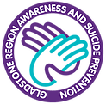  R U OK? Day | Man Walk  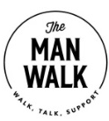 | Family Fun Day/  Bereavement Cruise | 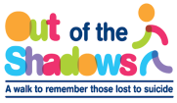  Out of the Shadows Walk | Strong Communities | Standby Support | Men’s Workshop | safeTALK
Visit www.ruok.org.au to purchase your merch  Let’s paint the town yellow  See the GRASP Facebook page for more info | 5.00pm  Man Walk  Meet at Entrance of East Shores, Goondoon Street | 10.00am-2.00pm  Family Fun Day with a “Suicide Bereavement Cruise” & fun for the kids  Tondoon Botanic Gardens | 5.00am-8.00am  Out of the Shadows Walk  Meet at Entrance of East Shores, Goondoon Street | 6.00pm-9.00pm  “Grief, Loss & Change” Workshop  VMR Building  Visit www.strongcommunities.org.au to book | 6.00pm-9.00pm  “What do I say what Do I Do” Bereavement Workshop  VMR Building  Text Mark on 0408 871 131 to book | 5.00pm-8.30pm  “Fear, Frustration & Anger” Men’s Workshop  Gladstone Mindcare Centre, 147 Goondoon Street  Text Mark on 0408 871 131 or Glen on  0419 750 607 | 6.00pm-9.00pm  Project  We Care’s  safeTALK  VMR Building  Text Mark on 0408 871 131 to book
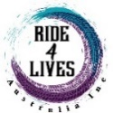
www.ride4lives.org
For more info, visit Ride4Lives Australia Inc’s Facebook page or website.
Limited numbers for the workshops – Book now!
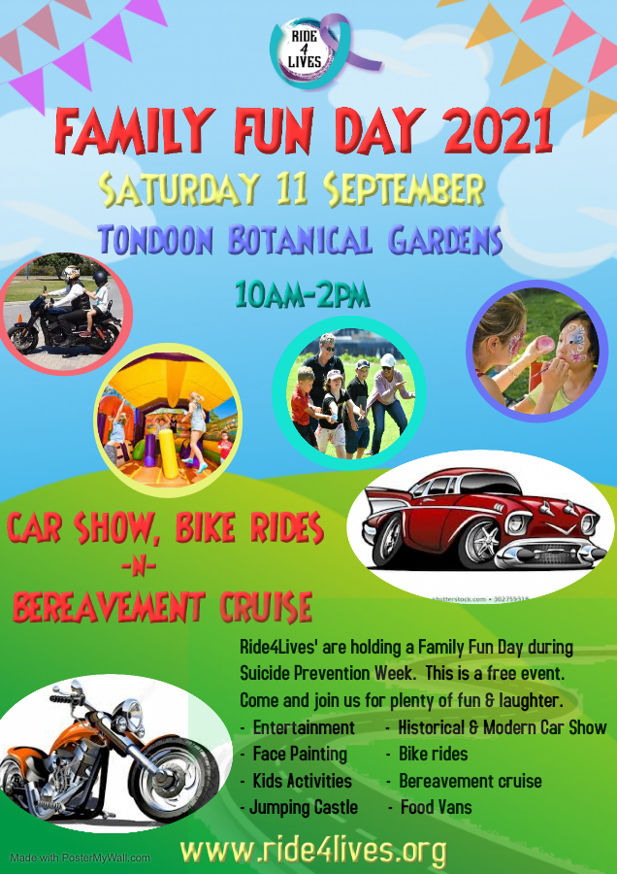
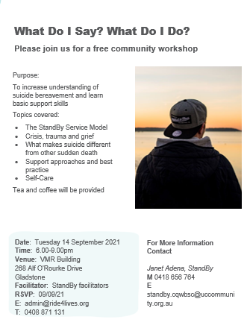

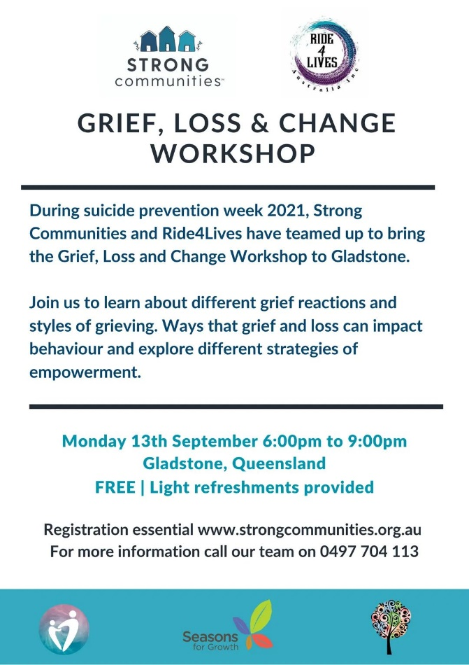
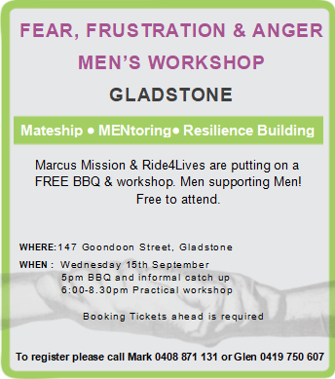
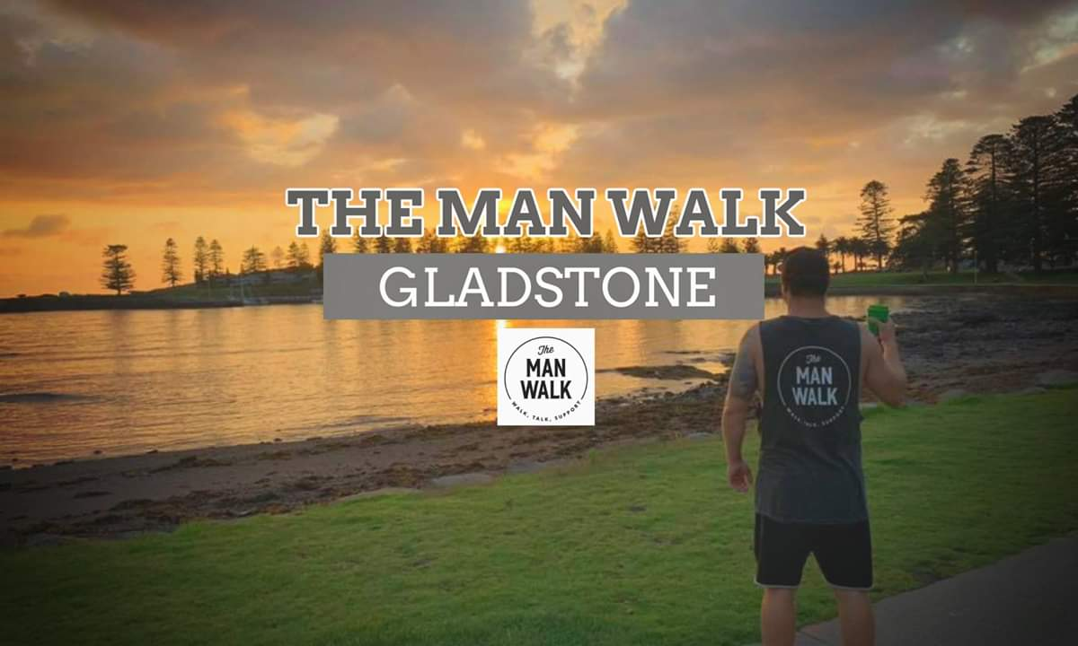
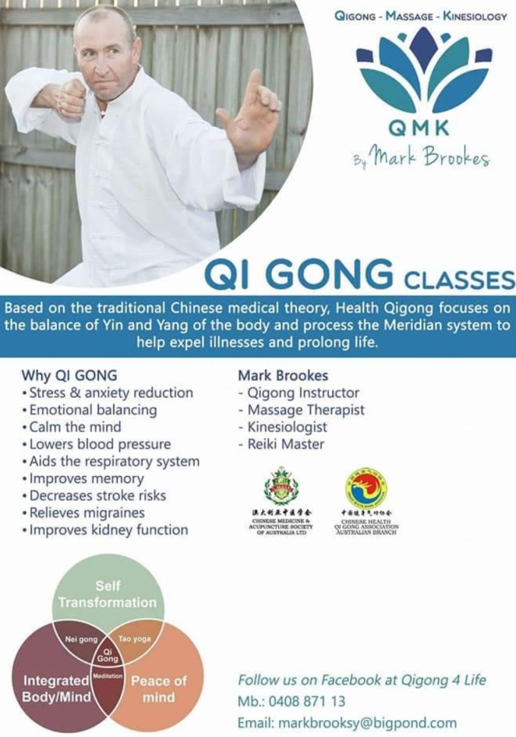
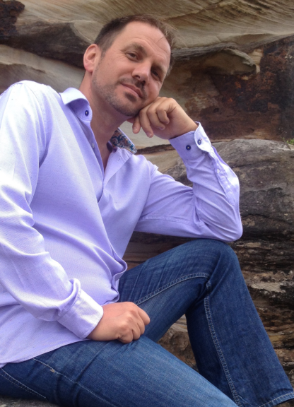
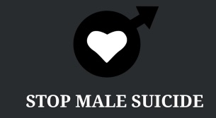
Every Friday @ 5.00pm - Meet at East Shores
Sunday 16 September - 10.00am
Qigong in the Park
Beach Cove, Spinnaker Park

Wednesday 12 September - 6.30pm
Glen Poole of Stop Male Suicide speaking on ‘How do we stop male suicide in Gladstone’
Gladstone Library, 39 Goondoon Street

